PART A

• echo "Hello, World!"

ANS :- echo is command and “Hello , World” is string we give to print.

• name="Productive"

ANS:- name is variable and Productive is a string given to variable name .

• touch file.txt

ANS:- touch is command for create a new Empty file and file.txt is stamp

• ls -a

ANS:- ls is command (List all files)and -a is for viewing the hidden files .

• rm file.txt

ANS:- rm is command this command is use to remove the file from directory

and we give to name this file which we want to remove.

• cp file1.txt file2.txt

ANS:-cp is command we use to copy content into another file and if

File is not there then that time create a new file and copy it.

• mv file.txt /path/to/directory/

ANS:- mv is command is use to move the file in one directory to

Another where we want we just give to the path name.

• chmod 755 script.sh

ANS:-chmod is command they give to change the permission and

755 is num. file permission for 7(read write and excute).

5-5(just read and excute).

• grep "pattern" file.txt

ANS:- grep is command we use to search the content of file and in “pattern”

In string we give and search matching content in the file.

• kill PID

ANS:- kill is command to use terminate the process and PID means

Process id which we want terminate.

• mkdir mydir && cd mydir && touch file.txt && echo "Hello, World!" > file.txt && cat file.txt

ANS:-mkdir is create a new directory and cd mydir change to the new directory touch is

create a new file echo is write to a string in file cat command is use see the content of file.

• ls -l | grep ".txt"

ANS:-ls -s command is use list out file with details and grep we use filter out who have .txt file

• cat file1.txt file2.txt | sort | uniq

ANS:-cat concenate the two file and sending combine output sort is arrange the alphabetical order

Uniq is remove the duplicate line and keep the unique lines .

• ls -l | grep "^d"

ANS:-ls -l is list out file with current directory and details and grep ^d this command is use match the starting d char in ls -l output .

• grep -r "pattern" /path/to/directory/

ANS:-grep -r is command to use search for recursively through out all the file and directoris

Top to bottom “pattern” is string and remain is path/to/directory where grep will search.

• cat file1.txt file2.txt | sort | uniq –d

ANS:-cat command is concenate the content in one file1 to file2 sort command is concenate output

In ascending order uniq-d command is use display only line which are repeated .

• chmod 644 file.txt

ANS:-chmod command is use for change the file permissions 644 are permission mode

6(read ,write), 4-4( read only ,read only).

• cp -r source_directory destination_directory

ANS:-cp -r command is for copy all file with subdirectoris with content .

Source directory:- this direc. U want to copy

Destination direc:- target location where u want to copy .

• find /path/to/search -name "*.txt"

ANS:-find is command is to find all file and directoris in hierarchy

Path/to/search – this directory where u find

-name- specifie to search for in this

*.txt is matching any file with .txt extension *is wildcard char matches.

• chmod u+x file.txt

ANS:-chmod is command is for change the file permission in directory

U stand for user owner of file

+ add the permission

X stand for excute the permission

File.txt this is file which are being the changed the permission.

• echo $PATH

ANS:-echo is command to use the print the text or char. In display terminal

$path is where stored the list of directories with separated by (:) colon.

PART B

**Identify True or False:**

1. ls is used to list files and directories in a directory.

ANS:- True

1. mv is used to move files and directories.

ANS:_ True

1. cd is used to copy files and directories.

ANS:- False

1. pwd stands for "print working directory" and displays the current directory.

ANS:- True

1. grep is used to search for patterns in files.

ANS:- True

1. chmod 755 file.txt gives read, write, and execute permissions to the owner, and read and execute permissions to group and others.

ANS:- True

1. mkdir -p directory1/directory2 creates nested directories, creating directory2 inside directory1 if directory1 does not exist.

ANS:- True

1. rm -rf file.txt deletes a file forcefully without confirmation.

ANS:- True

**Identify the Incorrect Commands:**

1. chmodx is used to change file permissions

ANS:- correct command is ( chmod )

1. cpy is used to copy files and directories.

ANS:- correct command is ( cp )

1. mkfile is used to create a new file.

ANS:- correct command is ( touch ).

1. catx is used to concatenate files.

ANS:- correct command is ( cat ).

1. rn is used to rename files.

ANS:- correct command is ( mv )

PART C

Question 1: Write a shell script that prints "Hello, World!" to the terminal

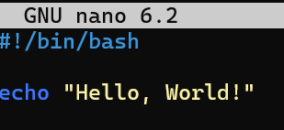.

Question 2: Declare a variable named "name" and assign the value "CDAC Mumbai" to it. Print the value of the variable.

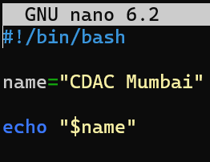

Question 3: Write a shell script that takes a number as input from the user and prints it.

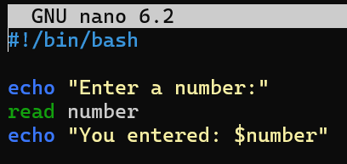

Question 4: Write a shell script that performs addition of two numbers (e.g., 5 and 3) and prints the result.

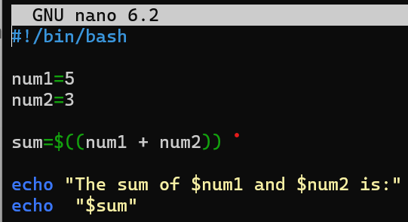

Question 5: Write a shell script that takes a number as input and prints "Even" if it is even, otherwise

prints "Odd".

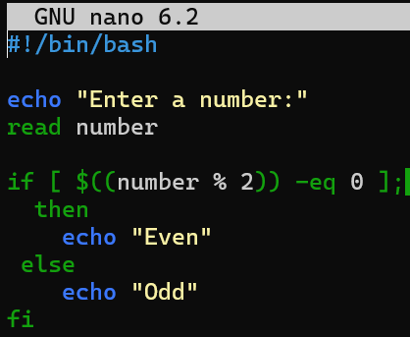

Question 6: Write a shell script that uses a for loop to print numbers from 1 to 5.

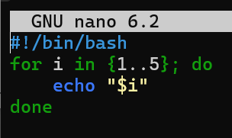

Question 7: Write a shell script that uses a while loop to print numbers from 1 to 5.

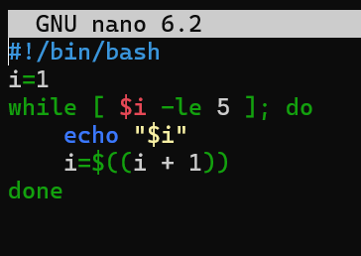

Question 8: Write a shell script that checks if a file named "file.txt" exists in the current directory. If it does, print "File exists", otherwise, print "File does not exist".

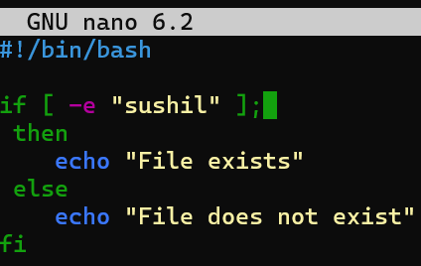

Question 9: Write a shell script that uses the if statement to check if a number is greater than 10 and prints a message accordingly.

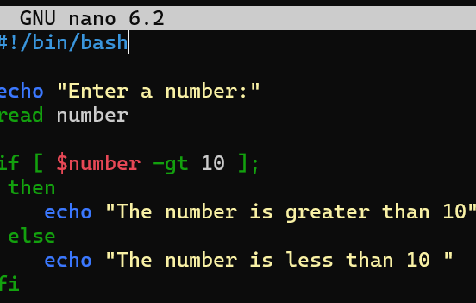

Question 10: Write a shell script that uses nested for loops to print a multiplication table for numbers from 1 to 5. The output should be formatted nicely, with each row representing a number and each column representing the multiplication result for that number.

[

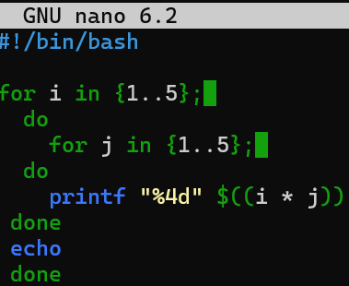

1. Consider the following processes with arrival times and burst times:
2. | Process | Arrival Time | Burst Time |
3. |---------|--------------|------------|
4. | P | 0 | 5 |
5. | P2 | 1 | 3 |
6. | P3 | 2 | 6 |

Calculate the average waiting time using First-Come, First-Served (FCFS) scheduling.

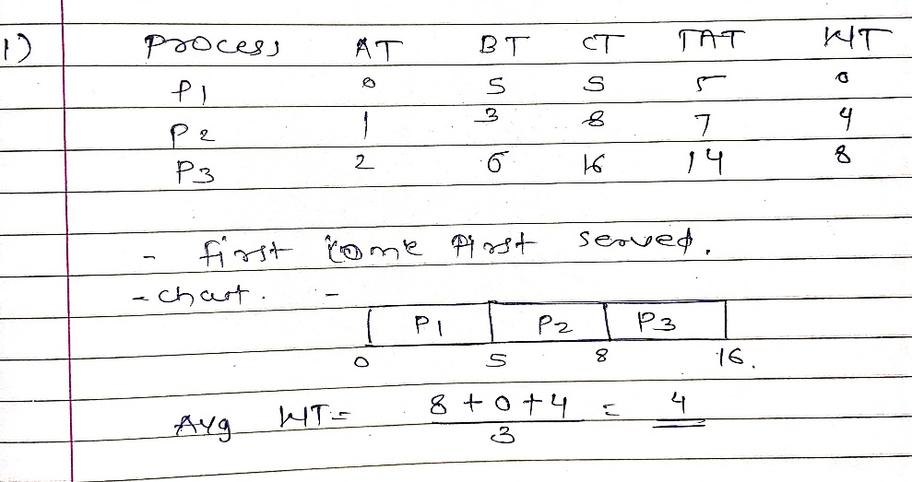

2. Consider the following processes with arrival times and burst times:

| Process | Arrival Time | Burst Time |

|---------|--------------|------------|

| P1 | 0 | 3 |

| P2 | 1 | 5 |

| P3 | 2 | 1 |

| P4 | 3 | 4 |

Calculate the average turnaround time using Shortest Job First (SJF) scheduling.

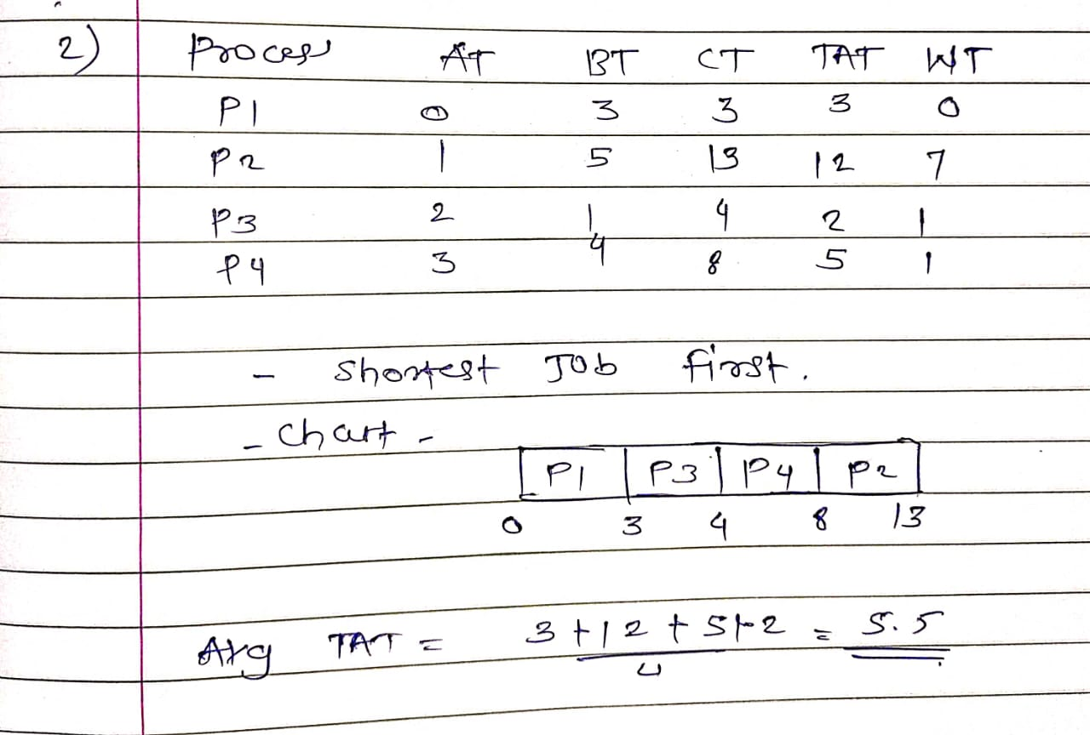

3. Consider the following processes with arrival times, burst times, and priorities (lower number

indicates higher priority):

| Process | Arrival Time | Burst Time | Priority |

|---------|--------------|------------|----------|

| P1 | 0 | 6 | 3 |

| P2 | 1 | 4 | 1 |

| P3 | 2 | 7 | 4 |

| P4 | 3 | 2 | 2 |

Calculate the average waiting time using Priority Scheduling.

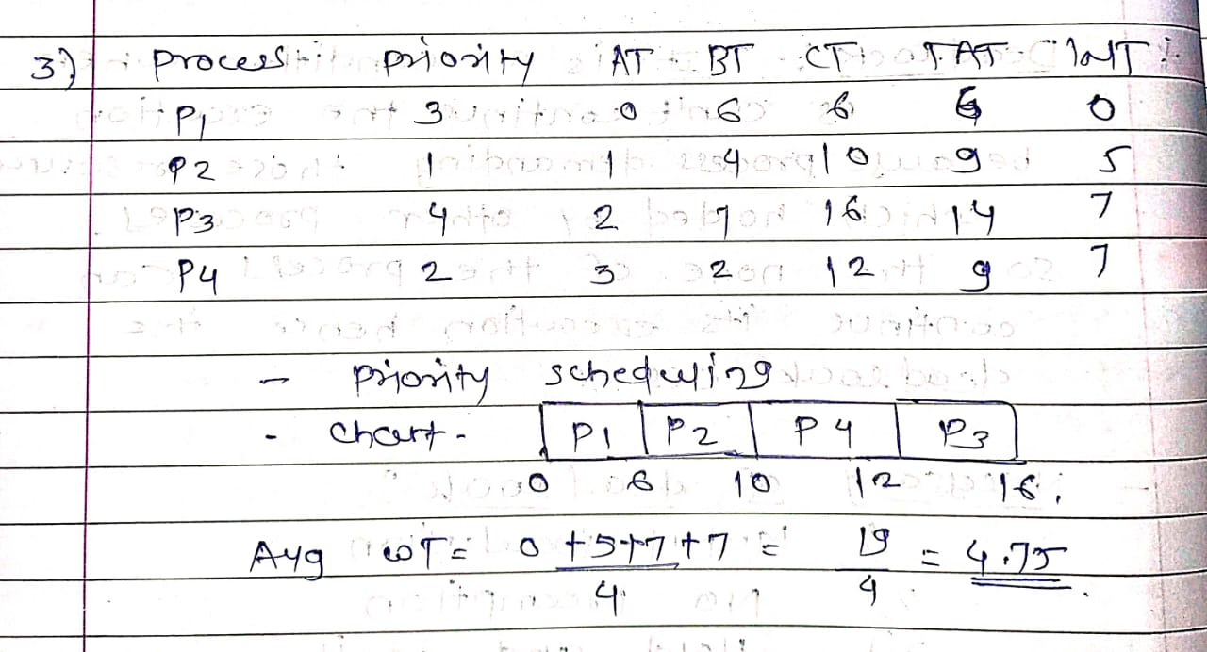

4. Consider the following processes with arrival times and burst times, and the time quantum for

Round Robin scheduling is 2 units:

| Process | Arrival Time | Burst Time |

|---------|--------------|------------|

| P1 | 0 | 4 |

| P2 | 1 | 5 |

| P3 | 2 | 2 |

| P4 | 3 | 3 |

Calculate the average turnaround time using Round Robin scheduling.

